Project 02 – Networks

Rajarshi Chattopadhyay  
RXC170010

[rajarshi.c@utdallas.edu](mailto:rajarshi.c@utdallas.edu)

1. Design

* Network Structure

Model(

(stem): Stem()

(body): Sequential(

(0): Layer(Sequential(XBlock()…))

(1): Layer(Sequential(XBlock()…))

(2): Layer(Sequential(XBlock()…))

(3): Layer(Sequential(XBlock()…)))

(head): Head()

)

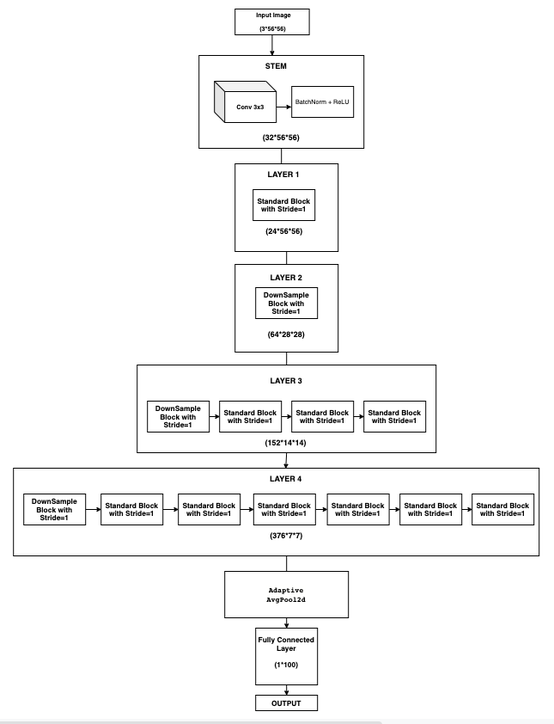

* Network standard building blocks

*Stem*

Stem(

(conv_3x3): Conv2d

(bn): BatchNorm2d

)

*XBlock*

XBlock(

(conv1_1x1): Conv2d

(bn1): BatchNorm2d

(conv2_3x3): Conv2d

(bn2): BatchNorm2d

(downsample): Downsample

(conv3_1x1): Conv2d

(bn3): BatchNorm2d

)

*Head*

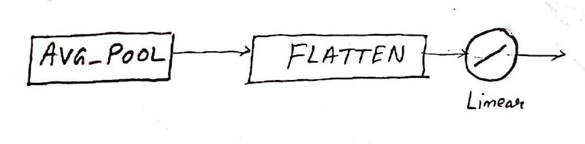

Head(

(avg_pool): AdaptiveAvgPool2d(output_size=1)

(f_out): Linear(in_features=376, out_features=100, bias=True)

)

Input

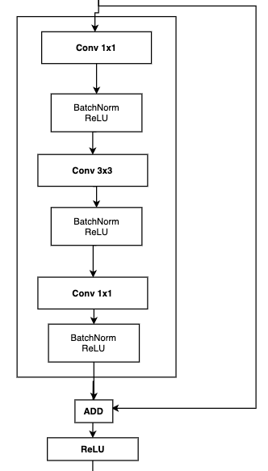

Output

Standard block, stride 1

The network down sampling building block

*Downsample*

Downsample(

(conv_1x1): Conv2d

(bn): BatchNorm2d

)

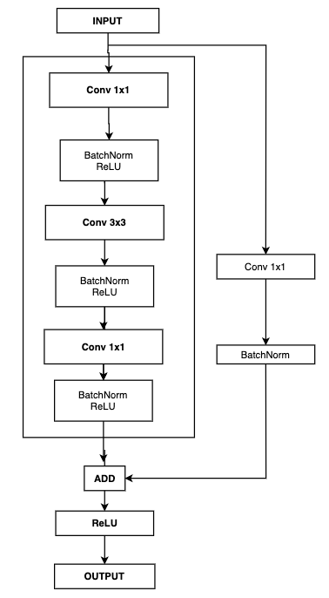

Downsample block, stride=2

Parameters

|  |  |
| --- | --- |
| channels | 3 |
| classes | 100 |
| network depth | 13 |
| initial width | 24 |
| slope | 36 |
| quantization | 2.5 |
| bottleneck ratio | 1 |
| group width | 8 |

Model(

(stem): Stem(

(conv_3x3): Conv2d(3, 32, kernel_size=(3, 3), stride=(1, 1), padding=(1, 1), bias=False)

(bn): BatchNorm2d(32, eps=1e-05, momentum=0.1, affine=True, track_running_stats=True)

)

(body): Sequential(

(0): Layer(

(layers): Sequential(

(0): XBlock(

(conv1_1x1): Conv2d(32, 32, kernel_size=(1, 1), stride=(1, 1), bias=False)

(bn1): BatchNorm2d(32, eps=1e-05, momentum=0.1, affine=True, track_running_stats=True)

(conv2_3x3): Conv2d(32, 32, kernel_size=(3, 3), stride=(1, 1), padding=(1, 1), groups=4, bias=False)

(bn2): BatchNorm2d(32, eps=1e-05, momentum=0.1, affine=True, track_running_stats=True)

(downsample): Downsample(

(conv_1x1): Conv2d(32, 24, kernel_size=(1, 1), stride=(1, 1), bias=False)

(bn): BatchNorm2d(24, eps=1e-05, momentum=0.1, affine=True, track_running_stats=True)

)

(conv3_1x1): Conv2d(32, 24, kernel_size=(1, 1), stride=(1, 1), bias=False)

(bn3): BatchNorm2d(24, eps=1e-05, momentum=0.1, affine=True, track_running_stats=True)

)

)

)

(1): Layer(

(layers): Sequential(

(0): XBlock(

(conv1_1x1): Conv2d(24, 24, kernel_size=(1, 1), stride=(1, 1), bias=False)

(bn1): BatchNorm2d(24, eps=1e-05, momentum=0.1, affine=True, track_running_stats=True)

(conv2_3x3): Conv2d(24, 24, kernel_size=(3, 3), stride=(2, 2), padding=(1, 1), groups=3, bias=False)

(bn2): BatchNorm2d(24, eps=1e-05, momentum=0.1, affine=True, track_running_stats=True)

(downsample): Downsample(

(conv_1x1): Conv2d(24, 64, kernel_size=(1, 1), stride=(2, 2), bias=False)

(bn): BatchNorm2d(64, eps=1e-05, momentum=0.1, affine=True, track_running_stats=True)

)

(conv3_1x1): Conv2d(24, 64, kernel_size=(1, 1), stride=(1, 1), bias=False)

(bn3): BatchNorm2d(64, eps=1e-05, momentum=0.1, affine=True, track_running_stats=True)

)

)

)

(2): Layer(

(layers): Sequential(

(0): XBlock(

(conv1_1x1): Conv2d(64, 64, kernel_size=(1, 1), stride=(1, 1), bias=False)

(bn1): BatchNorm2d(64, eps=1e-05, momentum=0.1, affine=True, track_running_stats=True)

(conv2_3x3): Conv2d(64, 64, kernel_size=(3, 3), stride=(2, 2), padding=(1, 1), groups=8, bias=False)

(bn2): BatchNorm2d(64, eps=1e-05, momentum=0.1, affine=True, track_running_stats=True)

(downsample): Downsample(

(conv_1x1): Conv2d(64, 152, kernel_size=(1, 1), stride=(2, 2), bias=False)

(bn): BatchNorm2d(152, eps=1e-05, momentum=0.1, affine=True, track_running_stats=True)

)

(conv3_1x1): Conv2d(64, 152, kernel_size=(1, 1), stride=(1, 1), bias=False)

(bn3): BatchNorm2d(152, eps=1e-05, momentum=0.1, affine=True, track_running_stats=True)

)

(1): XBlock(

(conv1_1x1): Conv2d(152, 152, kernel_size=(1, 1), stride=(1, 1), bias=False)

(bn1): BatchNorm2d(152, eps=1e-05, momentum=0.1, affine=True, track_running_stats=True)

(conv2_3x3): Conv2d(152, 152, kernel_size=(3, 3), stride=(1, 1), padding=(1, 1), groups=19, bias=False)

(bn2): BatchNorm2d(152, eps=1e-05, momentum=0.1, affine=True, track_running_stats=True)

(conv3_1x1): Conv2d(152, 152, kernel_size=(1, 1), stride=(1, 1), bias=False)

(bn3): BatchNorm2d(152, eps=1e-05, momentum=0.1, affine=True, track_running_stats=True)

)

(2): XBlock(

(conv1_1x1): Conv2d(152, 152, kernel_size=(1, 1), stride=(1, 1), bias=False)

(bn1): BatchNorm2d(152, eps=1e-05, momentum=0.1, affine=True, track_running_stats=True)

(conv2_3x3): Conv2d(152, 152, kernel_size=(3, 3), stride=(1, 1), padding=(1, 1), groups=19, bias=False)

(bn2): BatchNorm2d(152, eps=1e-05, momentum=0.1, affine=True, track_running_stats=True)

(conv3_1x1): Conv2d(152, 152, kernel_size=(1, 1), stride=(1, 1), bias=False)

(bn3): BatchNorm2d(152, eps=1e-05, momentum=0.1, affine=True, track_running_stats=True)

)

(3): XBlock(

(conv1_1x1): Conv2d(152, 152, kernel_size=(1, 1), stride=(1, 1), bias=False)

(bn1): BatchNorm2d(152, eps=1e-05, momentum=0.1, affine=True, track_running_stats=True)

(conv2_3x3): Conv2d(152, 152, kernel_size=(3, 3), stride=(1, 1), padding=(1, 1), groups=19, bias=False)

(bn2): BatchNorm2d(152, eps=1e-05, momentum=0.1, affine=True, track_running_stats=True)

(conv3_1x1): Conv2d(152, 152, kernel_size=(1, 1), stride=(1, 1), bias=False)

(bn3): BatchNorm2d(152, eps=1e-05, momentum=0.1, affine=True, track_running_stats=True)

)

)

)

(3): Layer(

(layers): Sequential(

(0): XBlock(

(conv1_1x1): Conv2d(152, 152, kernel_size=(1, 1), stride=(1, 1), bias=False)

(bn1): BatchNorm2d(152, eps=1e-05, momentum=0.1, affine=True, track_running_stats=True)

(conv2_3x3): Conv2d(152, 152, kernel_size=(3, 3), stride=(2, 2), padding=(1, 1), groups=19, bias=False)

(bn2): BatchNorm2d(152, eps=1e-05, momentum=0.1, affine=True, track_running_stats=True)

(downsample): Downsample(

(conv_1x1): Conv2d(152, 376, kernel_size=(1, 1), stride=(2, 2), bias=False)

(bn): BatchNorm2d(376, eps=1e-05, momentum=0.1, affine=True, track_running_stats=True)

)

(conv3_1x1): Conv2d(152, 376, kernel_size=(1, 1), stride=(1, 1), bias=False)

(bn3): BatchNorm2d(376, eps=1e-05, momentum=0.1, affine=True, track_running_stats=True)

)

(1): XBlock(

(conv1_1x1): Conv2d(376, 376, kernel_size=(1, 1), stride=(1, 1), bias=False)

(bn1): BatchNorm2d(376, eps=1e-05, momentum=0.1, affine=True, track_running_stats=True)

(conv2_3x3): Conv2d(376, 376, kernel_size=(3, 3), stride=(1, 1), padding=(1, 1), groups=47, bias=False)

(bn2): BatchNorm2d(376, eps=1e-05, momentum=0.1, affine=True, track_running_stats=True)

(conv3_1x1): Conv2d(376, 376, kernel_size=(1, 1), stride=(1, 1), bias=False)

(bn3): BatchNorm2d(376, eps=1e-05, momentum=0.1, affine=True, track_running_stats=True)

)

(2): XBlock(

(conv1_1x1): Conv2d(376, 376, kernel_size=(1, 1), stride=(1, 1), bias=False)

(bn1): BatchNorm2d(376, eps=1e-05, momentum=0.1, affine=True, track_running_stats=True)

(conv2_3x3): Conv2d(376, 376, kernel_size=(3, 3), stride=(1, 1), padding=(1, 1), groups=47, bias=False)

(bn2): BatchNorm2d(376, eps=1e-05, momentum=0.1, affine=True, track_running_stats=True)

(conv3_1x1): Conv2d(376, 376, kernel_size=(1, 1), stride=(1, 1), bias=False)

(bn3): BatchNorm2d(376, eps=1e-05, momentum=0.1, affine=True, track_running_stats=True)

)

(3): XBlock(

(conv1_1x1): Conv2d(376, 376, kernel_size=(1, 1), stride=(1, 1), bias=False)

(bn1): BatchNorm2d(376, eps=1e-05, momentum=0.1, affine=True, track_running_stats=True)

(conv2_3x3): Conv2d(376, 376, kernel_size=(3, 3), stride=(1, 1), padding=(1, 1), groups=47, bias=False)

(bn2): BatchNorm2d(376, eps=1e-05, momentum=0.1, affine=True, track_running_stats=True)

(conv3_1x1): Conv2d(376, 376, kernel_size=(1, 1), stride=(1, 1), bias=False)

(bn3): BatchNorm2d(376, eps=1e-05, momentum=0.1, affine=True, track_running_stats=True)

)

(4): XBlock(

(conv1_1x1): Conv2d(376, 376, kernel_size=(1, 1), stride=(1, 1), bias=False)

(bn1): BatchNorm2d(376, eps=1e-05, momentum=0.1, affine=True, track_running_stats=True)

(conv2_3x3): Conv2d(376, 376, kernel_size=(3, 3), stride=(1, 1), padding=(1, 1), groups=47, bias=False)

(bn2): BatchNorm2d(376, eps=1e-05, momentum=0.1, affine=True, track_running_stats=True)

(conv3_1x1): Conv2d(376, 376, kernel_size=(1, 1), stride=(1, 1), bias=False)

(bn3): BatchNorm2d(376, eps=1e-05, momentum=0.1, affine=True, track_running_stats=True)

)

(5): XBlock(

(conv1_1x1): Conv2d(376, 376, kernel_size=(1, 1), stride=(1, 1), bias=False)

(bn1): BatchNorm2d(376, eps=1e-05, momentum=0.1, affine=True, track_running_stats=True)

(conv2_3x3): Conv2d(376, 376, kernel_size=(3, 3), stride=(1, 1), padding=(1, 1), groups=47, bias=False)

(bn2): BatchNorm2d(376, eps=1e-05, momentum=0.1, affine=True, track_running_stats=True)

(conv3_1x1): Conv2d(376, 376, kernel_size=(1, 1), stride=(1, 1), bias=False)

(bn3): BatchNorm2d(376, eps=1e-05, momentum=0.1, affine=True, track_running_stats=True)

)

(6): XBlock(

(conv1_1x1): Conv2d(376, 376, kernel_size=(1, 1), stride=(1, 1), bias=False)

(bn1): BatchNorm2d(376, eps=1e-05, momentum=0.1, affine=True, track_running_stats=True)

(conv2_3x3): Conv2d(376, 376, kernel_size=(3, 3), stride=(1, 1), padding=(1, 1), groups=47, bias=False)

(bn2): BatchNorm2d(376, eps=1e-05, momentum=0.1, affine=True, track_running_stats=True)

(conv3_1x1): Conv2d(376, 376, kernel_size=(1, 1), stride=(1, 1), bias=False)

(bn3): BatchNorm2d(376, eps=1e-05, momentum=0.1, affine=True, track_running_stats=True)

)

)

)

)

(head): Head(

(avg_pool): AdaptiveAvgPool2d(output_size=1)

(f_out): Linear(in_features=376, out_features=100, bias=True)

)

)

1. Training

* Hyperparameters

|  |  |
| --- | --- |
| learning rate max value | 0.001 |
| learning rate initial | 0.001*0.01 |
| initial epochs | 5 |
| learning rate final | 0.001*0.01 |
| final epochs | 35 |

Error: Cross Entropy Loss

Optimizer: Adam Optimizer(learning rate: 0.001)

* Training loss and accuracy per epoch

Epoch 1 lr = 0.000010 avg_loss = 0.009097 accuracy = 2.60% time = 178.71s

Epoch 2 lr = 0.000208 avg_loss = 0.007510 accuracy = 13.32% time = 179.47s

Epoch 3 lr = 0.000406 avg_loss = 0.006559 accuracy = 22.92% time = 179.63s

Epoch 4 lr = 0.000604 avg_loss = 0.005941 accuracy = 29.32% time = 179.19s

Epoch 5 lr = 0.000802 avg_loss = 0.005484 accuracy = 35.53% time = 178.96s

Epoch 6 lr = 0.001000 avg_loss = 0.005128 accuracy = 37.39% time = 179.47s

Epoch 7 lr = 0.000994 avg_loss = 0.004745 accuracy = 41.93% time = 179.42s

Epoch 8 lr = 0.000975 avg_loss = 0.004455 accuracy = 44.88% time = 179.25s

Epoch 9 lr = 0.000944 avg_loss = 0.004225 accuracy = 41.62% time = 178.97s

Epoch 10 lr = 0.000902 avg_loss = 0.004031 accuracy = 49.37% time = 179.24s

Epoch 11 lr = 0.000848 avg_loss = 0.003858 accuracy = 51.45% time = 179.34s

Epoch 12 lr = 0.000784 avg_loss = 0.003703 accuracy = 51.50% time = 179.25s

Epoch 13 lr = 0.000710 avg_loss = 0.003568 accuracy = 53.65% time = 179.17s

Epoch 14 lr = 0.000627 avg_loss = 0.003435 accuracy = 53.04% time = 179.21s

Epoch 15 lr = 0.000537 avg_loss = 0.003316 accuracy = 57.88% time = 179.16s

Epoch 16 lr = 0.000440 avg_loss = 0.003171 accuracy = 58.96% time = 179.17s

Epoch 17 lr = 0.000337 avg_loss = 0.003054 accuracy = 59.72% time = 179.55s

Epoch 18 lr = 0.000230 avg_loss = 0.002947 accuracy = 61.72% time = 179.24s

Epoch 19 lr = 0.000121 avg_loss = 0.002842 accuracy = 62.76% time = 179.35s

Epoch 20 lr = 0.000010 avg_loss = 0.002756 accuracy = 63.19% time = 179.19s

Epoch 21 lr = 0.000010 avg_loss = 0.002747 accuracy = 63.15% time = 179.57s

Epoch 22 lr = 0.000010 avg_loss = 0.002733 accuracy = 63.04% time = 179.52s

Epoch 23 lr = 0.000010 avg_loss = 0.002725 accuracy = 63.09% time = 179.41s

Epoch 24 lr = 0.000010 avg_loss = 0.002723 accuracy = 63.15% time = 179.43s

Epoch 25 lr = 0.000010 avg_loss = 0.002704 accuracy = 63.39% time = 179.57s

Epoch 26 lr = 0.000010 avg_loss = 0.002713 accuracy = 63.43% time = 179.56s

Epoch 27 lr = 0.000010 avg_loss = 0.002700 accuracy = 63.43% time = 179.36s

Epoch 28 lr = 0.000010 avg_loss = 0.002702 accuracy = 63.24% time = 179.30s

Epoch 29 lr = 0.000010 avg_loss = 0.002701 accuracy = 63.24% time = 179.76s

Epoch 30 lr = 0.000010 avg_loss = 0.002699 accuracy = 63.32% time = 179.49s

Epoch 31 lr = 0.000010 avg_loss = 0.002697 accuracy = 63.41% time = 179.67s

Epoch 32 lr = 0.000010 avg_loss = 0.002691 accuracy = 63.30% time = 179.61s

Epoch 33 lr = 0.000010 avg_loss = 0.002687 accuracy = 63.32% time = 179.46s

Epoch 34 lr = 0.000010 avg_loss = 0.002681 accuracy = 63.39% time = 179.36s

Epoch 35 lr = 0.000010 avg_loss = 0.002688 accuracy = 63.35% time = 178.65s

Epoch 36 lr = 0.000010 avg_loss = 0.002681 accuracy = 63.43% time = 179.29s

Epoch 37 lr = 0.000010 avg_loss = 0.002678 accuracy = 63.52% time = 179.02s

Epoch 38 lr = 0.000010 avg_loss = 0.002676 accuracy = 63.45% time = 179.11s

**Epoch 39 lr = 0.000010 avg_loss = 0.002681 accuracy = 63.56% time = 178.97s**

Epoch 40 lr = 0.000010 avg_loss = 0.002667 accuracy = 63.22% time = 179.32s

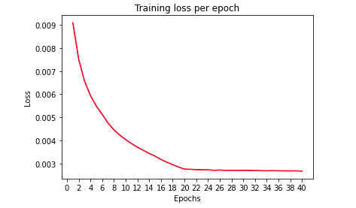

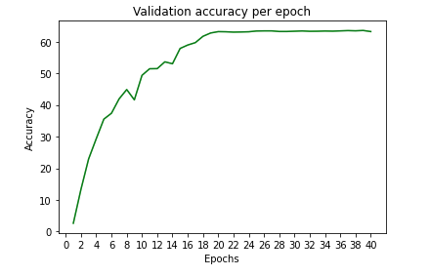

* Testing Accuracy

Testing Accuracy of test set = 63.22%

Class accuracy:

Accuracy of plane = 82.00

Accuracy of car = 70.00

Accuracy of bird = 66.00

Accuracy of cat = 68.00

Accuracy of deer = 54.00

Accuracy of dog = 48.00

Accuracy of frog = 58.00

Accuracy of horse = 48.00

Accuracy of ship = 94.00

Accuracy of truck = 64.00

1. Implementation

MACs and parameters per operator

----------------------------------------------------------------

Layer (type) Output Shape Param #

================================================================

Conv2d-1 [-1, 32, 56, 56] 864

BatchNorm2d-2 [-1, 32, 56, 56] 64

Stem-3 [-1, 32, 56, 56] 0

Conv2d-4 [-1, 32, 56, 56] 1,024

BatchNorm2d-5 [-1, 32, 56, 56] 64

Conv2d-6 [-1, 32, 56, 56] 2,304

BatchNorm2d-7 [-1, 32, 56, 56] 64

Conv2d-8 [-1, 24, 56, 56] 768

BatchNorm2d-9 [-1, 24, 56, 56] 48

Conv2d-10 [-1, 24, 56, 56] 768

BatchNorm2d-11 [-1, 24, 56, 56] 48

Downsample-12 [-1, 24, 56, 56] 0

XBlock-13 [-1, 24, 56, 56] 0

Layer-14 [-1, 24, 56, 56] 0

Conv2d-15 [-1, 24, 56, 56] 576

BatchNorm2d-16 [-1, 24, 56, 56] 48

Conv2d-17 [-1, 24, 28, 28] 1,728

BatchNorm2d-18 [-1, 24, 28, 28] 48

Conv2d-19 [-1, 64, 28, 28] 1,536

BatchNorm2d-20 [-1, 64, 28, 28] 128

Conv2d-21 [-1, 64, 28, 28] 1,536

BatchNorm2d-22 [-1, 64, 28, 28] 128

Downsample-23 [-1, 64, 28, 28] 0

XBlock-24 [-1, 64, 28, 28] 0

Layer-25 [-1, 64, 28, 28] 0

Conv2d-26 [-1, 64, 28, 28] 4,096

BatchNorm2d-27 [-1, 64, 28, 28] 128

Conv2d-28 [-1, 64, 14, 14] 4,608

BatchNorm2d-29 [-1, 64, 14, 14] 128

Conv2d-30 [-1, 152, 14, 14] 9,728

BatchNorm2d-31 [-1, 152, 14, 14] 304

Conv2d-32 [-1, 152, 14, 14] 9,728

BatchNorm2d-33 [-1, 152, 14, 14] 304

Downsample-34 [-1, 152, 14, 14] 0

XBlock-35 [-1, 152, 14, 14] 0

Conv2d-36 [-1, 152, 14, 14] 23,104

BatchNorm2d-37 [-1, 152, 14, 14] 304

Conv2d-38 [-1, 152, 14, 14] 10,944

BatchNorm2d-39 [-1, 152, 14, 14] 304

Conv2d-40 [-1, 152, 14, 14] 23,104

BatchNorm2d-41 [-1, 152, 14, 14] 304

XBlock-42 [-1, 152, 14, 14] 0

Conv2d-43 [-1, 152, 14, 14] 23,104

BatchNorm2d-44 [-1, 152, 14, 14] 304

Conv2d-45 [-1, 152, 14, 14] 10,944

BatchNorm2d-46 [-1, 152, 14, 14] 304

Conv2d-47 [-1, 152, 14, 14] 23,104

BatchNorm2d-48 [-1, 152, 14, 14] 304

XBlock-49 [-1, 152, 14, 14] 0

Conv2d-50 [-1, 152, 14, 14] 23,104

BatchNorm2d-51 [-1, 152, 14, 14] 304

Conv2d-52 [-1, 152, 14, 14] 10,944

BatchNorm2d-53 [-1, 152, 14, 14] 304

Conv2d-54 [-1, 152, 14, 14] 23,104

BatchNorm2d-55 [-1, 152, 14, 14] 304

XBlock-56 [-1, 152, 14, 14] 0

Layer-57 [-1, 152, 14, 14] 0

Conv2d-58 [-1, 152, 14, 14] 23,104

BatchNorm2d-59 [-1, 152, 14, 14] 304

Conv2d-60 [-1, 152, 7, 7] 10,944

BatchNorm2d-61 [-1, 152, 7, 7] 304

Conv2d-62 [-1, 376, 7, 7] 57,152

BatchNorm2d-63 [-1, 376, 7, 7] 752

Conv2d-64 [-1, 376, 7, 7] 57,152

BatchNorm2d-65 [-1, 376, 7, 7] 752

Downsample-66 [-1, 376, 7, 7] 0

XBlock-67 [-1, 376, 7, 7] 0

Conv2d-68 [-1, 376, 7, 7] 141,376

BatchNorm2d-69 [-1, 376, 7, 7] 752

Conv2d-70 [-1, 376, 7, 7] 27,072

BatchNorm2d-71 [-1, 376, 7, 7] 752

Conv2d-72 [-1, 376, 7, 7] 141,376

BatchNorm2d-73 [-1, 376, 7, 7] 752

XBlock-74 [-1, 376, 7, 7] 0

Conv2d-75 [-1, 376, 7, 7] 141,376

BatchNorm2d-76 [-1, 376, 7, 7] 752

Conv2d-77 [-1, 376, 7, 7] 27,072

BatchNorm2d-78 [-1, 376, 7, 7] 752

Conv2d-79 [-1, 376, 7, 7] 141,376

BatchNorm2d-80 [-1, 376, 7, 7] 752

XBlock-81 [-1, 376, 7, 7] 0

Conv2d-82 [-1, 376, 7, 7] 141,376

BatchNorm2d-83 [-1, 376, 7, 7] 752

Conv2d-84 [-1, 376, 7, 7] 27,072

BatchNorm2d-85 [-1, 376, 7, 7] 752

Conv2d-86 [-1, 376, 7, 7] 141,376

BatchNorm2d-87 [-1, 376, 7, 7] 752

XBlock-88 [-1, 376, 7, 7] 0

Conv2d-89 [-1, 376, 7, 7] 141,376

BatchNorm2d-90 [-1, 376, 7, 7] 752

Conv2d-91 [-1, 376, 7, 7] 27,072

BatchNorm2d-92 [-1, 376, 7, 7] 752

Conv2d-93 [-1, 376, 7, 7] 141,376

BatchNorm2d-94 [-1, 376, 7, 7] 752

XBlock-95 [-1, 376, 7, 7] 0

Conv2d-96 [-1, 376, 7, 7] 141,376

BatchNorm2d-97 [-1, 376, 7, 7] 752

Conv2d-98 [-1, 376, 7, 7] 27,072

BatchNorm2d-99 [-1, 376, 7, 7] 752

Conv2d-100 [-1, 376, 7, 7] 141,376

BatchNorm2d-101 [-1, 376, 7, 7] 752

XBlock-102 [-1, 376, 7, 7] 0

Conv2d-103 [-1, 376, 7, 7] 141,376

BatchNorm2d-104 [-1, 376, 7, 7] 752

Conv2d-105 [-1, 376, 7, 7] 27,072

BatchNorm2d-106 [-1, 376, 7, 7] 752

Conv2d-107 [-1, 376, 7, 7] 141,376

BatchNorm2d-108 [-1, 376, 7, 7] 752

XBlock-109 [-1, 376, 7, 7] 0

Layer-110 [-1, 376, 7, 7] 0

AdaptiveAvgPool2d-111 [-1, 376, 1, 1] 0

Linear-112 [-1, 100] 37,700

Head-113 [-1, 100] 0

================================================================

Total params: 2,275,604

Trainable params: 2,275,604

Non-trainable params: 0

----------------------------------------------------------------

Input size (MB): 0.04

Forward/backward pass size (MB): 28.28

Params size (MB): 8.68

Estimated Total Size (MB): 36.99

----------------------------------------------------------------

1. Extra

* **Learning rate scheduling** has been done with a linear increase for the first 5 epochs and then a Cosine decay for the final 35 epochs. (cnn.py)
* **Checkpointing** of the trained model have been done after every epoch so that in case RAM crashes, or execution is interrupted, the last saved model can be retrieved, and training can be continued. (cnn.py)
* **Early stopping** functionality has been implemented to stop training if 5 consecutive epochs do not lead to a decrease in average training loss. (cnn.py)
* A function has been created that also **prints the weights in each operator** in the network in the model summary. (extra.py)
* The model has been **visualized using torchviz** by forward propagating a zero input through the model. (extra.py)
* The model visualization has been done and exported as ***cnn.onnx*** file which can be viewed using ***Netron***. (extra.py)